To access OAAPS you will need to activate an Okta account. This is a new single sign-on (SSO) service that will enable you to convienently accesss your ACL applications, including OAAPS, through a single, secure home page. Follow the steps below to activate your account.



Quick Reference Guide

**Activating an Okta Account**

##### To activate an Okta account

1. Check your email for an invitation to join the Okta SSO service. Depending on your mailbox settings, the email may be sent to your spam or junk folder. The email should resemble the image below:

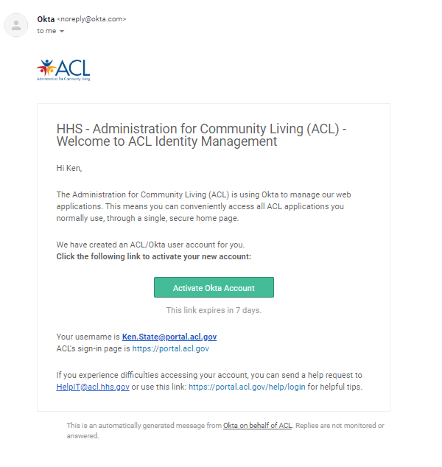

1. In bottom of the email, locate your username. You will need this for logging into OAAPS.
2. In the email, select **Activate Okta Account**.
3. On the registration page, enter a password and choose a security question.

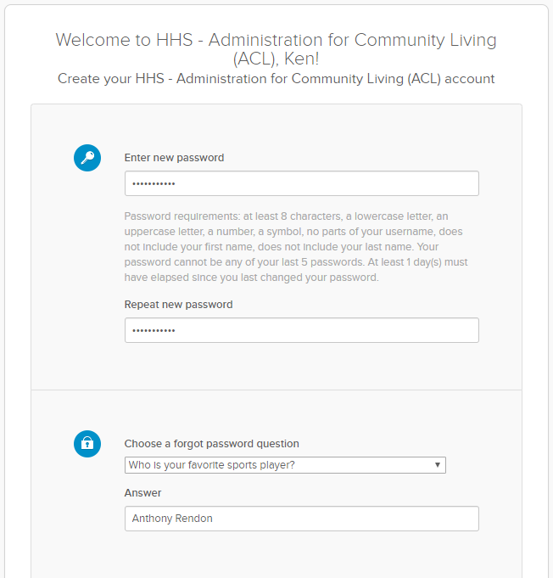

1. Scroll down until you see the two sections about adding phone numbers, as shown below. These fields enable you to enter a phone number that will be used for recovering your password via text message (SMS) or voice call. If you wish to do so, select **Add Phone Number**.

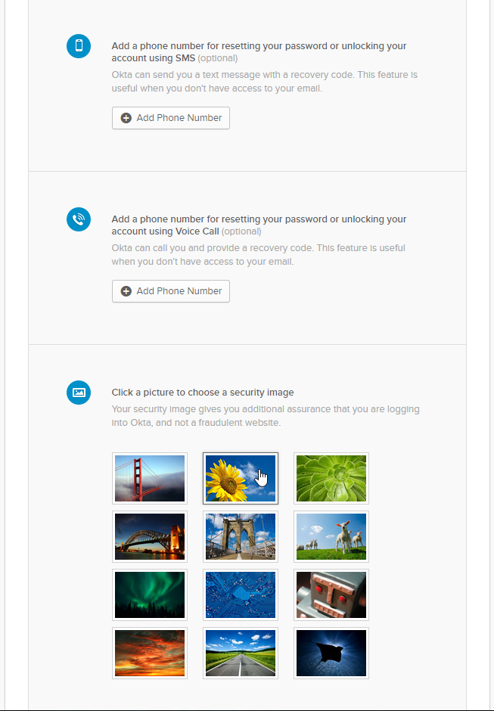

1. In the Forgot Password window, enter the mobile phone number you provided in the “Add a Phone Number” field which will be used for resetting your password.

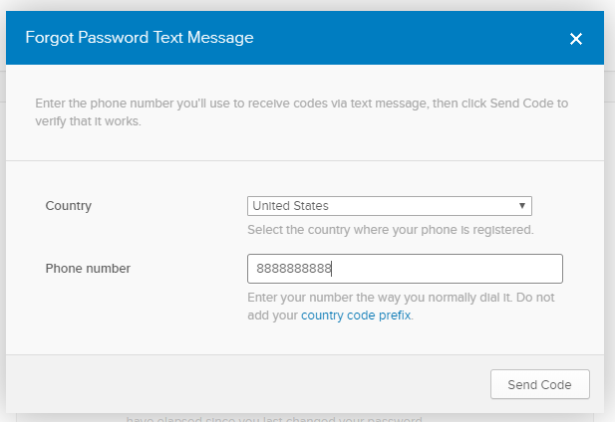

1. Select **Send Code**.
2. If the number is successfully verified, you will receive a green verified message. After reviewing the message, select **Done**.

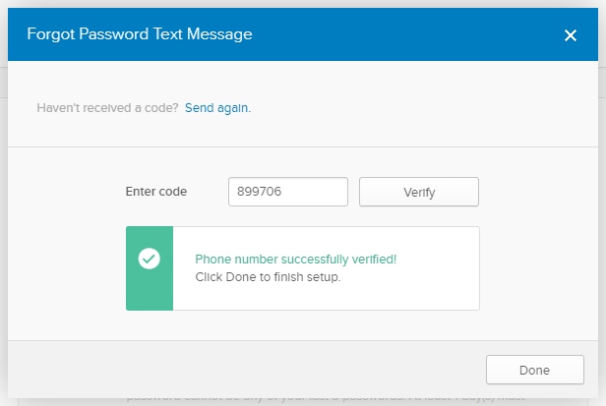

1. Scroll down to the security image section and choose a security image.

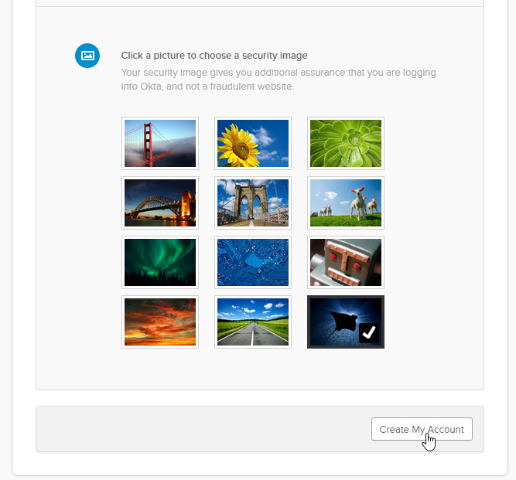

1. Select **Create My Account**.
2. You will be redirected to the Okta dashboard, which will look similar to the images below:

Application, screenshot of an Okta dashboard.

*NOTE: You may or may not have apps assigned to your account. However, this should not prevent you from accessing OAAPS. In other words, you may disregard the Okta message about browser plugin and go directly to the OAAPS as outlined below.*

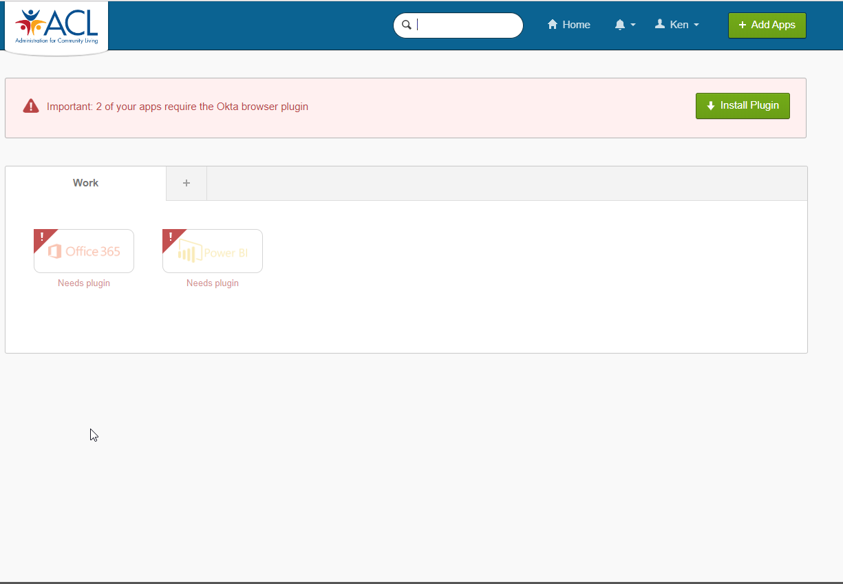

1. Go to OAAPS by clicking on the OAAPS app or by using the following link: <https://oaaps.acl.gov> (Or alternatively, copy and paste or type the address into your browser’s search engine.)

NOTE: It is recommended that you access OAAPS from a Chrome, Firefox, or Edge browser. Do NOT use Internet Explorer.

1. On the OAAPS home page, select **Sign In**.



1. In the Sign in popup, enter the username and password.

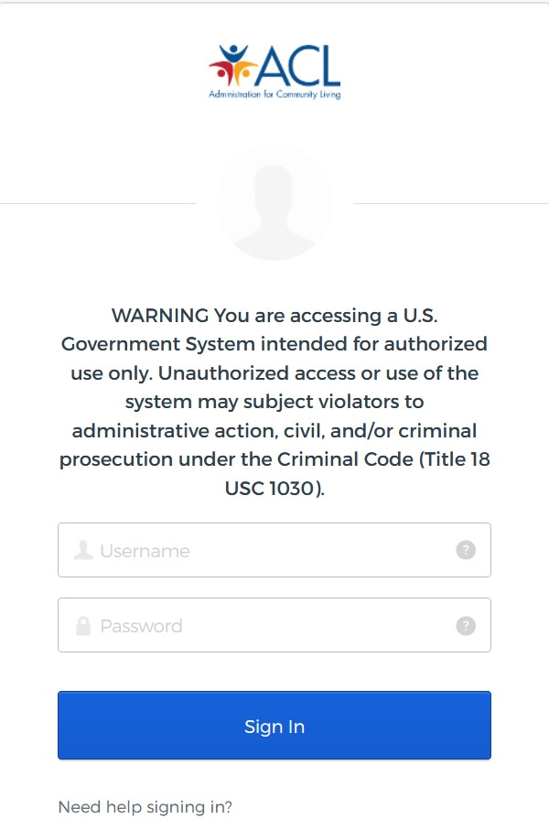

1. Select **Sign in**.

Once signed in, the OAAPS Dashboard will display.

If a user is unable to sign into OAAPS right away, wait for 10 minutes to give the system time to update. Then, try logging in again.